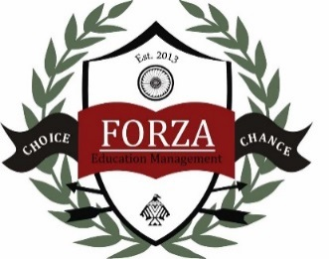
Child Development Center
2019-2020 VPK Wrap-around Supply List
- 1 box of 8 count large Crayola crayons
- 2 boxes of 24 count Crayola crayons
- 2 boxes of wide tip Crayola markers – set of 10 classic colors
- 1 box of colored pencils
- 1 watercolor paint set – GIRLS only
- 4 packages of glue sticks
- Scissors (Fiskars blunt/rounded tip)
- 1 package of #2 yellow pencils
- 2 plastic folders with pockets
- Package of dry erase markers – BOYS only
- 1 clear plastic pencil box
- 1 one inch 3-ring binder (white with a clear pocket front)
- Package of construction paper
- 1 ream of white copy paper
- 3 boxes of tissues
- 3 packages of baby wipes
- 1 container of Clorox wipes
- 1 box of gallon sized Ziplock bags – BOYS only
- 1 box of sandwich sized Ziplock bage – GIRLS only
- 1 nap time blanket (no larger than 40”x60”) clearly labeled
with your child’s name on it. (No pillows please)
- 2 full changes of clothing stored in Ziplock bags with your
child’s name clearly labeled on each item.

Please have your child keep any valuable items at home as they might become lost
while at school. This includes all toys, jewelry, fancy hair accessories, etc.
Thank you! ☺

